A CRM APPLICATION FOR
THECHAISHOP&CO
Project Documentation

Student Name: M Dhivya
College Name: Vallalar Arts and Science College-Co-Ed, Vadalur.
Salesforce Org Username: dhivya702230.7cb693836f77@agentforce.com
Group Members: B Bhavana, V Kanimozhi, R Keerthana

INTRODUCTION

1.Project Overview:
The project “A CRM Application for TheChaiShop&Co” focuses on developing a
Salesforce-based Customer Relationship Management (CRM) system to manage
customer, employer, and enterprise accounts efficiently. The system automates sales
processes, maintains customer records, generates reports, and improves customer
engagement through automated notifications.

2.User Story:
As a sales representative at TheChaiShop&Co, I want to efficiently manage customer
relationships and streamline sales processes using our CRM application.
I want to easily access and update employer details, as well as distinguish between online
and offline customer records using record types, allowing for personalized interactions.
Additionally, I need the application to automate sales calculations, such as order quantity
and total bill amount, to ensure accurate and efficient transactions.
Moreover, I require the ability to generate insightful reports and dashboards to summarize
and analyse sales data effectively, aiding in decision-making and strategy development.
Lastly, I would like the application to automate email notifications to customers on their
birthdays, informing them of special offers tailored to celebrate their special day,
enhancing customer engagement and loyalty.

PROJECT PLANNING

● The project followed an Agile-based development approach with defined
milestones and sprints.
● A Salesforce Developer account was created to set up the development
environment.
● Custom objects were designed to store customer, employer, and enterprise data.
● Custom tabs and a Lightning Application were developed for easy system
navigation.
● Fields, relationships, and global picklists were configured to ensure data
consistency.
● Page layouts and record types were created based on user roles and customer
categories.
● Validation rules were implemented to prevent incorrect data entry.
● Email templates and automated flows were developed for customer notifications.
● Reports and dashboards were created for performance monitoring and analysis.
● Regular sprint reviews and testing were conducted to track progress and resolve
issues.
● The project was completed within the planned timeline through systematic
scheduling.

PROJECT DEVELOPMENT PHASE

Milestone 1: Creation of developer account
Milestone 2: Object Creation
Milestone 3: Tabs
Milestone 4: The Lightning App
Milestone 5: Global Picklist
Milestone 6: Fields and Relationships
Milestone 7: Creation of Page Layout

STEP-BY-STEP IMPLEMENTATION

Milestone 1: Developer Account Creation

Description
Created and registered a Special Developer Edition Org.
Screenshot:
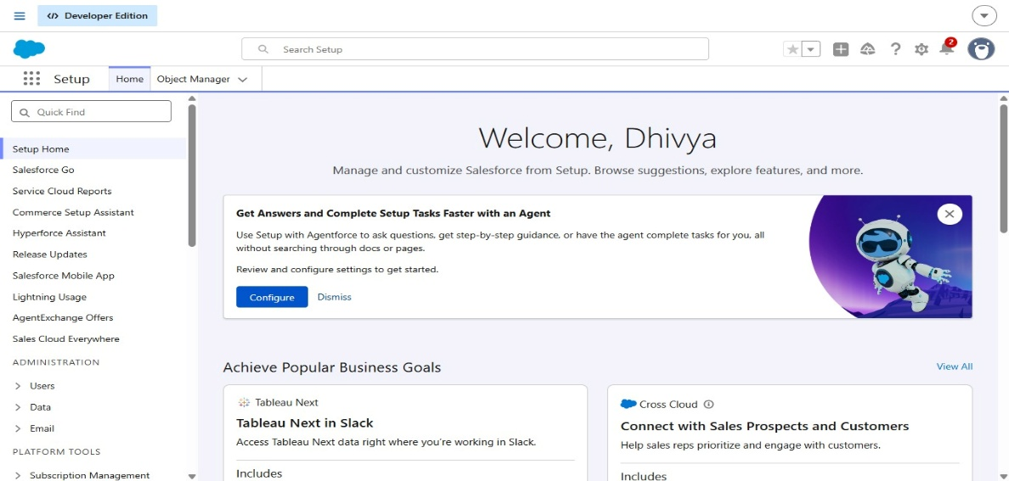

Milestone 2: Custom Object Creation

Description:
Created initial custom objects (`Employer Account`, `Customer Account`, `Enterprise Account`).
Screenshots:
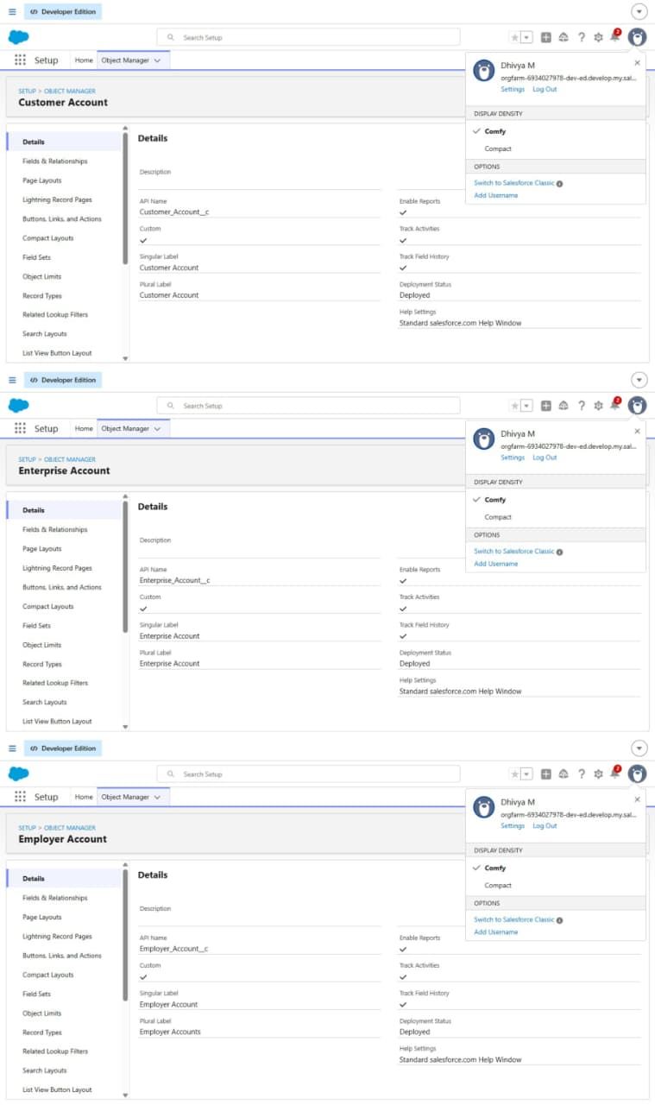

Milestone 3: tabs
Created custom tabs for custom objects (`Employer Account`, `Customer Account`, `Enterprise Account`).
Screenshot:
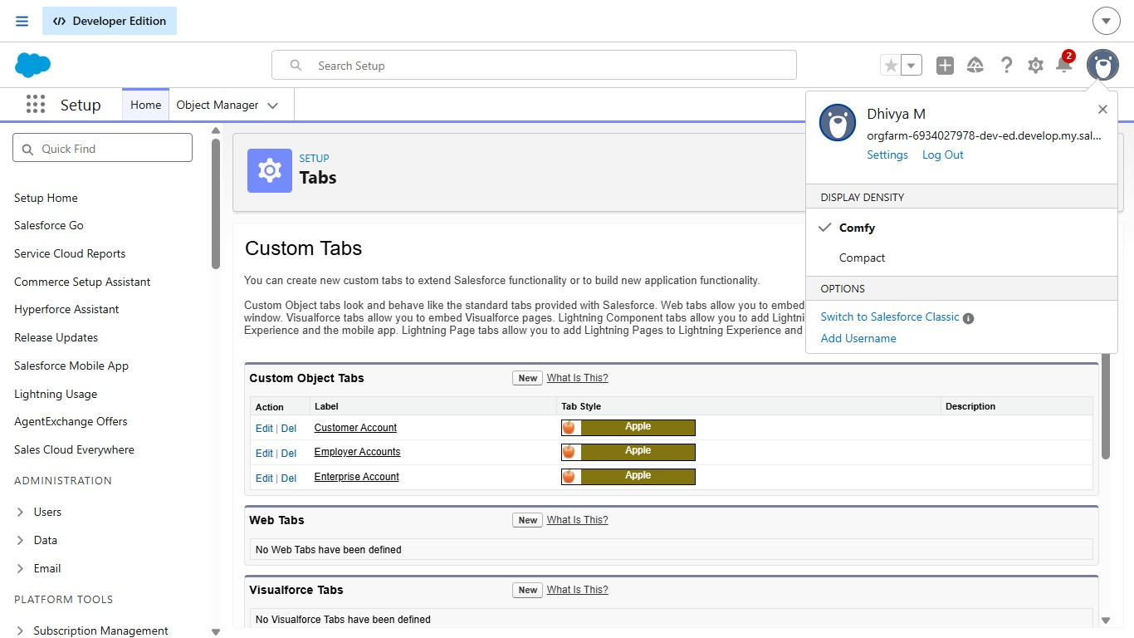

Milestone 4: Lightning Application

Description:
Configured the custom Lightning App (e.g., `Chai Shop and Go`) with standard/custom tabs and assigned the `System Administrator` profile.
Screenshot:
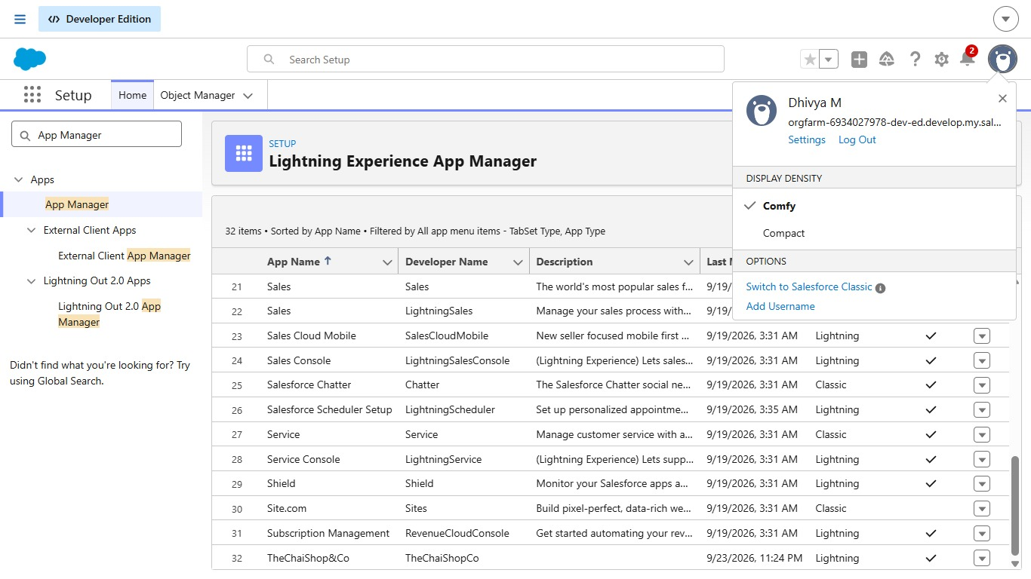
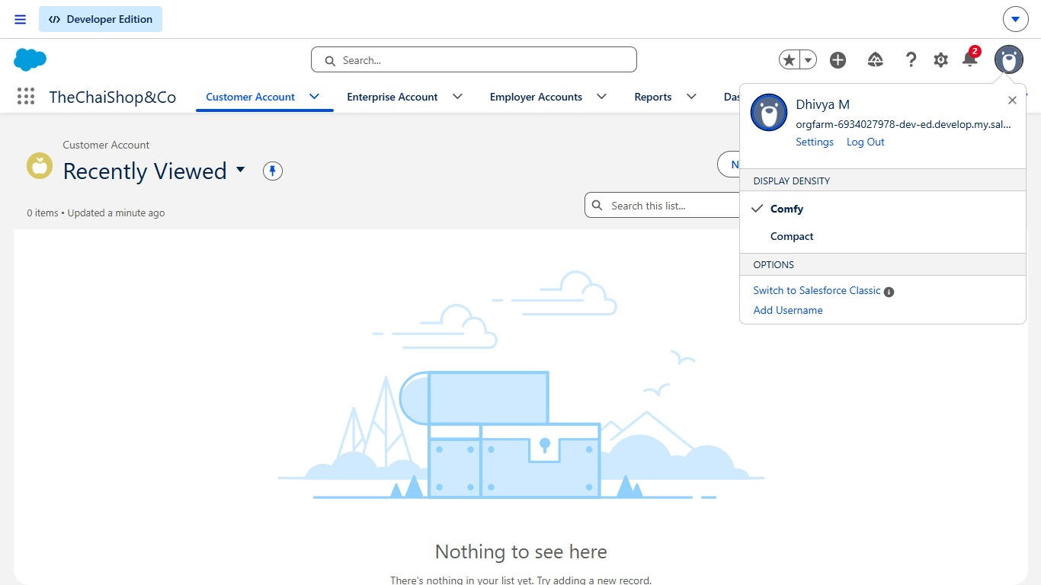

Milestone 5: Global Picklists

Description:
Set up global picklist value sets (e.g., `Gender`, `Related Items`, `Payment Options`).
Screenshot:
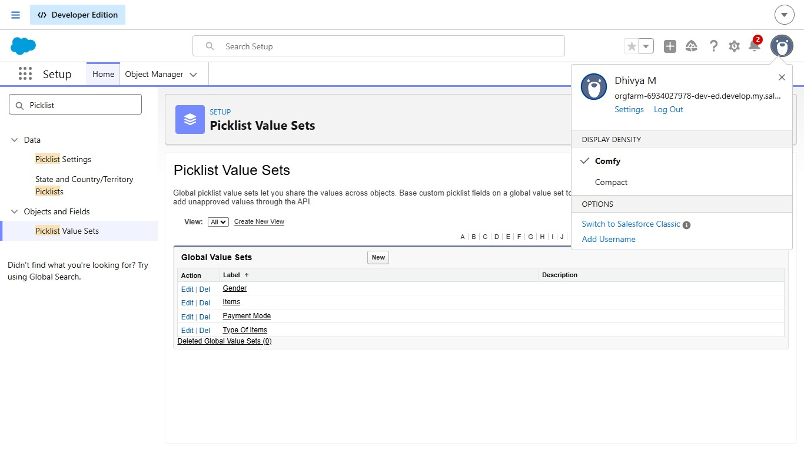

Milestone 6: Custom Field

Description:
Added custom text fields (such as `First Name`, `Last Name`) and other data types to custom objects.
Screenshot:
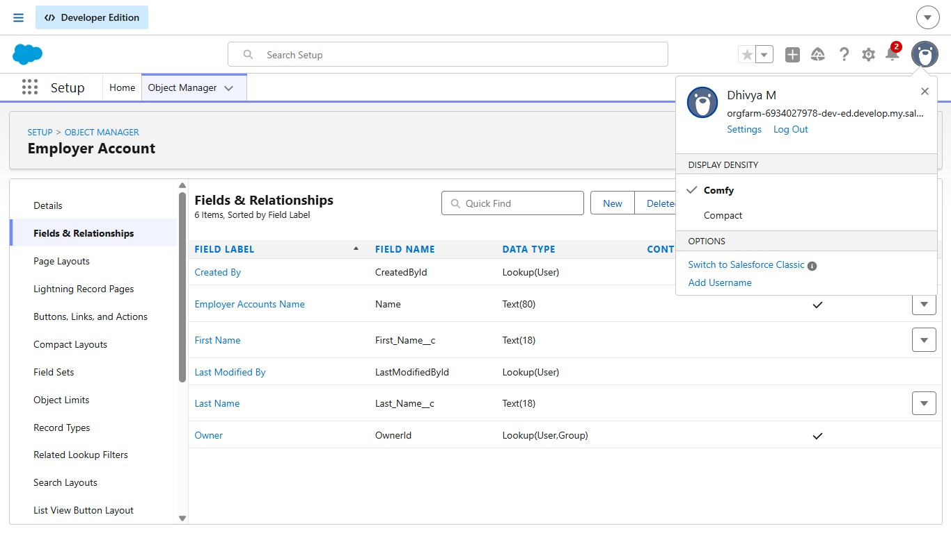

Milestone 7: Custom Page Layouts
Description:
Designed and customized page layouts (e.g., `Online Orders`) to organize fields and buttons cleanly.
Screenshot:

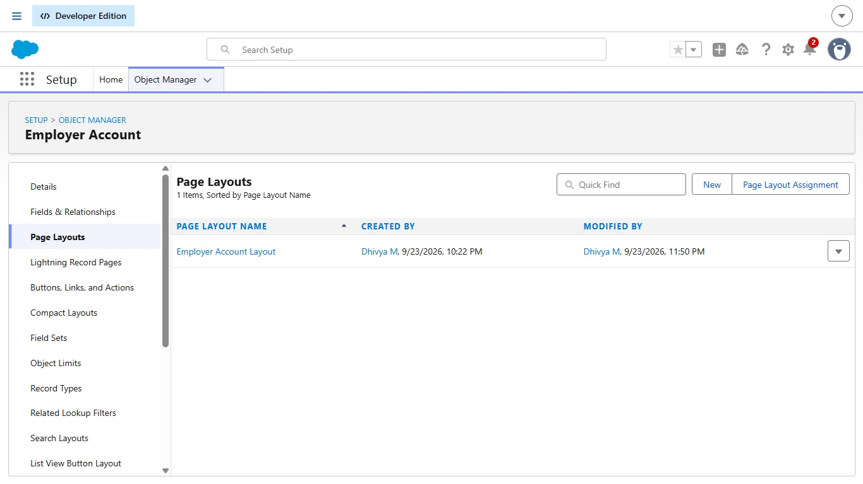
ADVANTAGES & DISADVANTAGES
Advantages
● Centralized data management
● Reduced manual work
● Automated calculations
● Improved customer engagement
● Real-time analytics

Disadvantages
● Requires Salesforce license
● Internet dependency
● Limited offline access

CONCLUSION
The CRM Application for TheChaiShop&Co successfully improves business operations
by integrating customer data, automating billing, and enabling intelligent reporting. The
system reduces errors, saves time, and enhances customer relationships through
automation and analytics.

FUTURE SCOPE
● Mobile CRM integration
● AI-based sales prediction
● WhatsApp/SMS alerts
● Inventory management
● Multi-branch support
● Advanced customer profiling

APPENDIX
Source Code: Salesforce Configuration & Flows
Dataset: Customer and Sales Records
Tools Used: Salesforce Developer Org

